DESIGN
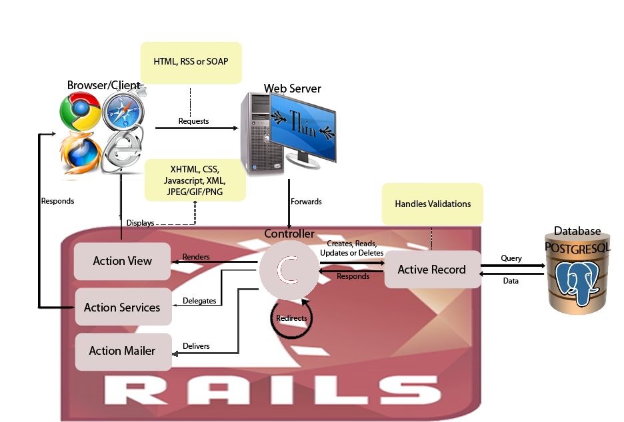
- System Architecture

Figure 1 The OASIS System Architecture.

